**5.1Home Page:**

This page is design as a home page. It provides options for the jobseeker and employer. After selecting one of the options, response directly goes to the Home page of the selected user. And other necessary links are also available on this page..

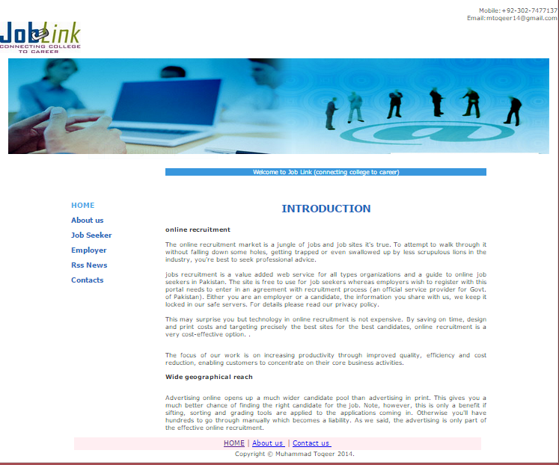

**5.2 Jobseeker:**

This page is design as jobseeker home page. The jobseeker can upload his resume, he can view current job list and also their details, he can apply for specific job and he can also view news updates of different categories from different channels. There are also many other options available.

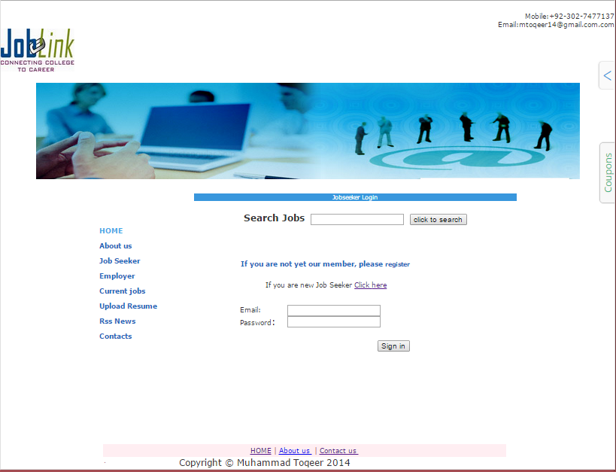

**5.3 Upload Resume:**

This page is used to upload the jobseeker resume. To upload resume, the jobseeker must give the Resume subject and file path

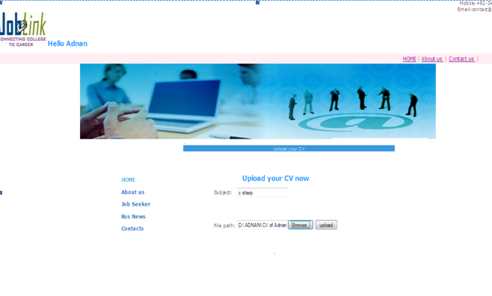

**5.4 RSS NEWS:**

This page is design to view news. After selecting the channel, its updated news will display on that page.

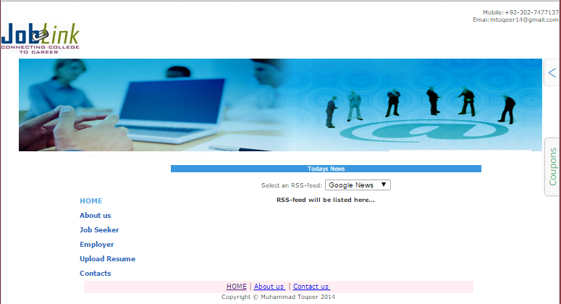

**5.5 Employer:**

This page is design as employer home page. After login, this page will display to the user. A list of previous for posted jobs will display on this page. This page has option for post new job, view news, view my profile and view applicants. There are also many other options available.

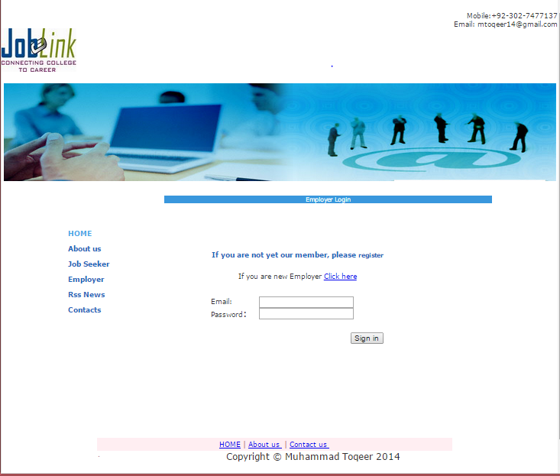

**5.6 Registration:**

This page is design to make an employer an authorized person. After the registration of employer he can post new jobs.

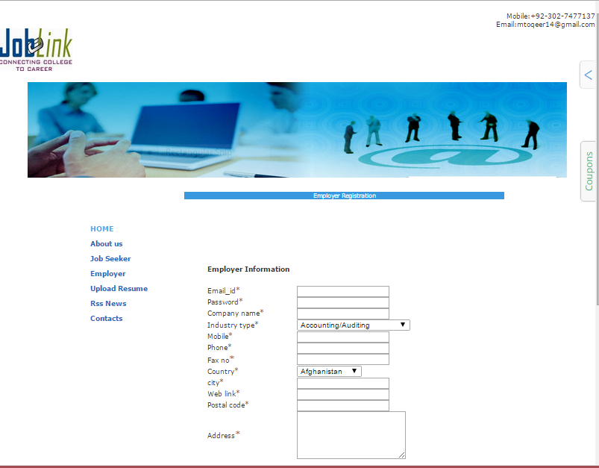

**5.7 Employer Profile:**

This page is design to view employers. A list of employers will display on that page. It has also option to view applicant’s educational profile. There are also many other options available.

